WHY

Text 1

I. summarize each paragraph in one sentence or phrase

|  |  |
| --- | --- |
| Text | Summary |
| Now that we’re getting a grip on food waste and plastic waste, we really need to make a start on fashion waste – and end this fad of “fast fashion”. The MPs on the Environment Select Committee suggest we could start small, with a tax of one penny per clothing item, which would yield about £35m a year, something that could fund better clothing collection – for charity, reuse or recycling. |  |
| It should work. Yet we can go further. As the now well-developed understanding of “nudge” incentives predicts, the public has a disproportionate tendency to react to relatively small taxes. Or can do. In recent times we have seen it most dramatically in the sugar tax, first in Scotland then across the UK, which will yield huge benefits to theNational Health Service as children in particular move to lower-sugar substitutes. |  |
| We should start doing something similar with fashion. We could, at its simplest, add a tiny amount to the value-added tax (VAT) on adult’s clothing, and reduce the VAT on clothing repairs. |  |
| Perhaps that would also make us think twice about the modern habit of ultra-disposable clothing, a trend which is down to three factors. First, the availability of much cheaper clothing generally, often derived from low or poverty-wage economies in Asia, specifically countries such as Bangladesh, where many of the fast fashion manufacturing factories are based. Second, our incomes are higher than they were, and clothing a comparatively smaller item in household budgets, so we’re less inclined to be careful about our purchases. Third, and this pains me more than anything, the very idea of good quality, value for money and above all durable clothes has, so to speak, gone out of fashion. |  |
| To start you off, you can do what I often do. Without embarrassing yourself, and with no necessary requirement to disclose it to anyone but your conscience, conduct a little audit of what you have on. Think about how long you’ve had it, and what it cost. One day you, like me, may take especial pride and delight in wearing a tie or a jacket from some decades ago. I can roughly date some of mine because they still have “St Michael” on them, the M&S brand that was discontinued in 2000. |  |
| The next step is to start maintaining your clothes, not throwing them away. If there’s a bit of tearing on the lining, why not have it repaired by a tailor or seamstress. Holes in socks can be darned; elbow pads added to elderly tweed jackets; buttons replaced. One day, wearing timeless, classic lines season-in, season-out will be the fashionable thing to do and we will stop throwing away perfectly serviceable clothing. |  |

II. What is the issue?

III. Mind-map

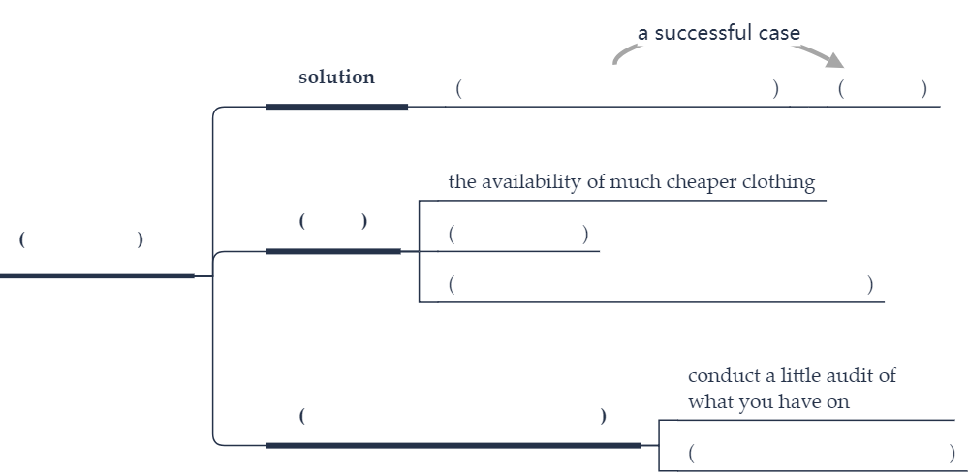

Text 2

I. summarize each paragraph in one sentence or phrase

|  |  |
| --- | --- |
| Text | Summary |
| You may find it a little eerie to discover that you are being rated by the companies you buy things from, and that the quality of customer service you receive can be determined by your “customer lifetime value” score. Maybe it reminds you too much of China’s new social credit system, which is intended to allow the government to keep tabs on citizens’ anti-social behaviors — and punish them by cutting off privileges like intercity train travel if they’re noncompliant. |  |
| Better get used to it. We are no longer rated by only the credit reporting agencies, which are subject to extensive federal regulation. Even companies that don’t directly assign us ratings are effectively quantifying our habits as consumers, borrowers, investors and producers. Big data starts with us, the subjects. And the inevitable, necessary, economically efficient use of big data entails constant analysis and evaluation. In the face of sophisticated data analysis, ratings are actually a rather crude measure — the least intrusive, most easily conceived evidence that almost nothing we do anymore is free from systemic quantification. |  |
| Why is this rating and quantification happening? Can we do anything about it? The explanation lies mostly in computing power. Going back at least to the 1960s, social scientists realized that they could extract significant information, and make fairly reliable predictions, based on individuals’ demographic information. For decades, businesses used ZIP codes as a proxy for that predictive information. |  |
| It’s not that businesses of yore couldn’t gather data about their customers. They could, and did. Their problem was that the data was only as useful as the analytical tools available to process it. Early computers — as well as their successors up until perhaps a decade ago — simply lacked the capacity to break down and analyze vast quantities of data to produce useful outcomes. |  |
| Moore’s law gradually changed that. Although it (probably) cannot go on forever, the effective doubling of computing power every two years has led to more and more powerful processing. Today’s computers can process so much data that it’s now possible to extract information about you individually from collected records of your behavior. |  |
| To possess that information is to possess value. Any company that ranks my lifetime value can do more than just use that information to make informed decisions about how to interact with me. It can sell my customer lifetime value score to another, analogous enterprise. |  |
| The only conceivable ways for this state of affairs to change are extreme self-restraint — like, not using online vendors and services — or government regulation. The former is unrealistic; we’re not going back to a bricks-and-mortar, cash-only society. The latter is conceivable, but we’re still very far from a clear consensus about what regulation could or should achieve. |  |

II. What is the issue?

III. Mind-map

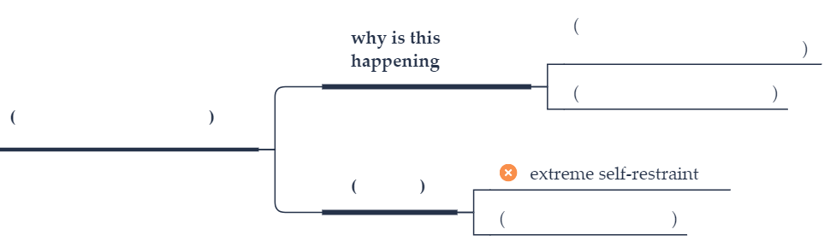

Text 3

I. summarize each paragraph in one sentence or phrase

|  |  |
| --- | --- |
| Text | Summary |
| Davos is here again this week. The small mountain town in Switzerland, a health spa before it became a ski resort, is host once again to the annual meeting of the global elite, the industrialists, politicians and other leaders who run the world economy, at the World Economic Forum. |  |
| Unsurprisingly, it is an event that has come under attack, for it exemplifies all that the populist movement despises: rich people who fly in their private jets to Davos to give lectures about the need to cut carbon emissions. And when politicians run into problems at home they don’t want to be seen lording it among the elite. |  |
| This year, Donald Trump has pulled out the American delegation because of the government shutdown, and for obvious reasons, neither Emmanuel Macron nor Theresa May are attending either. |  |
| There are, however, at least three important reasons for welcoming Davos this particular year. The first is that it is focusing on social and environmental issues, and that any attention here generates impact beyond the meetings. |  |
| The broadcaster and naturalist Sir David Attenborough is speaking about biodiversity and will be receiving an award. Prince William will interview him, and later speak at another session on mental health. Raising awareness about mental health, and seeking ways to treat it more effective must surely be one of the key priorities for the global community. |
| The second reason is that the World Economic Forum’s administration has been one of the pioneers in analysing and assessing the impact of the new technologies, such as Artificial Intelligence, on the workplace. |  |
| In 2016 the WEF’s founder, Professor Klaus Schwab, published his study of this process under the title of The Fourth Industrial Revolution. He developed these ideas further with Shaping the Future of the Fourth Industrial Revolution last year. |
| We are all aware how jobs are being both created and destroyed by technology, but governments are struggling to cope with the social and economic changes that are happening as a result. The WEF has drawn attention to some of the issues it raises, and by doing so will help nudge governments towards a more effective response. |
| And third, at a time when globalisation is under threat, is it worth remembering that on balance it has brought great benefits to society. Anyone reading these words, flashed instantly around the world, will be doing so thanks to the technologies that globalisation has created and shared. |  |

II. What is the issue?

III. Mind-map

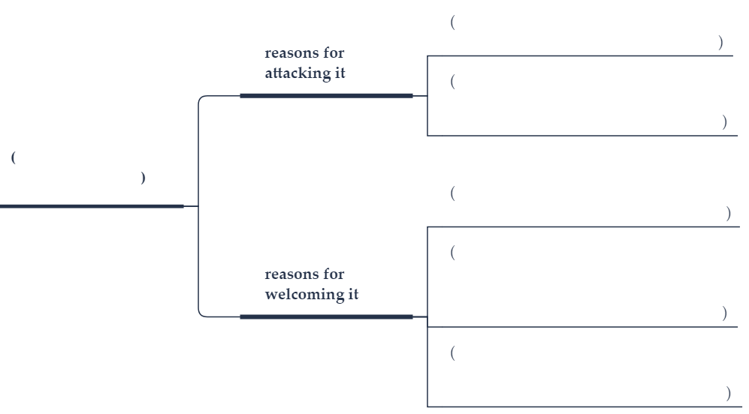

Text 4

I. summarize each paragraph in one sentence or phrase

|  |  |
| --- | --- |
| Text | Summary |
| Despite the media attention on them, neither the Syrian civilians who have fled war in the Middle East nor the Rohingya Muslims who have fled repression in Myanmar are the world’s largest group of displaced people. That record goes to 4.1 million people dislodged in Congo. |  |
| The little-noticed crisis in the heart of Africa has worsened over the past year to the point that the European Union and the United Nations announced this week that they are seeking to double foreign aid to the Democratic Republic of Congo, which is four times as large as France. An estimated 7 million Congolese are considered to be “food insecure.” Only 1 in 7 earns more than $1.25 a day. Last October, the UN refugee agency declared a Level 3 emergency in parts of Congo, the highest possible ranking. |  |
| The country’s woes stem from two major conflicts less than two decades ago that have left a governance emptiness. Some 120 rebel groups are fighting either for ethnic dominance or to control the country’s vast mineral wealth, which is estimated at $24 trillion. |  |
| Yet the biggest crisis is whether President Joseph Kabila, who has ruled for 16 years and remains very unpopular, intends to hold elections and step down as he has promised. In recent months, his forces have killed nearly a dozen people in peaceful protests called by the Roman Catholic secular leaders. Another protest is called for Feb. 25. (Also, this week, Switzerland imposed sanctions on 14 allies of Mr. Kabila who might have stored ill-gotten wealth in Swiss banks.) |  |
| Both the political crisis and the violence of the military groups make it difficult for foreign groups to reach the millions of people in need. The situation in Congo is not the image that Africans want to project to the world just when they are hailing the version of a fictional and wise African nation, Wakanda, in the Marvel movie “Black Panther.” |  |
| In recent weeks, the continent has seen two democratic successes with the disposition of corrupt presidents in Zimbabwe and South Africa. Now it may be Congo’s turn. Its people have a strong national identity and a desire for properly elected leaders. With more foreign assistance, they might be able to be the next success story in Africa. |  |

II. What is the issue?

III. Mind-map



Text 5

I. summarize each paragraph in one sentence or phrase

|  |  |
| --- | --- |
| Text | Summary |
| Dramatic increases in the rate at which ice on Greenland and East Antarctica is melting are among the latest manifestations of the changes our planet and its atmosphere are undergoing. Concerns surrounding the risk of melting ice causing sea levels to rise were previously focused mainly on large glaciers. But scientists have discovered that the largest recent losses from Greenland’s vast ice sheet, which is two miles thick in places, have occurred in the island’s largely glacier-free south-west. Combined with recent analysis of retreating Antarctic glaciers that were previously thought to be stable, this new research makes discouraging reading. This is because of what it tells us about the extent of likely sea level rises, and warming seas linked to coral die-off and chaotic weather, but also because it highlights the difficulty of fully understanding the climate system. |  |
| Last year the UN’s Intergovernmental Panel on Climate Change urged governments to work towards the most ambitious targets in the 2015 Paris agreement, and a global temperature rise not greater than 1.5C. Many experts fear that factors including the election of Donald Trump in the US and Jair Bolsonaro in Brazil mean that even the more modest goal of sticking to current commitments, putting the world on course for a 3C rise, remains a huge challenge. Currently, global carbon emissions are still rising. But if people all over the world are getting used to the idea that higher temperatures and increased frequency of extreme weather events are the new normal, we are arguably less advanced in our understanding of warming oceans. |  |
| The sea level rises that scientists expect to accompany a temperature rise of 3C would submerge cities including Shanghai, Osaka and Miami along with parts of Rio de Janeiro and Alexandria – less than a century from now. Among nations, Bangladesh will be particularly severely affected, with one estimate suggesting that 250,000 people are already forced to move each year, making them environmental refugees. Such facts on the ground, as well as predictions, are why climate activists have long linked their cause to wider concerns around social justice. Just as carbon emissions must be limited to protect the livelihoods of people already struggling in areas vulnerable to drought and desertification, sea level rises must be restricted to protect the millions of people who live on coasts and in low-lying areas. The movement of peoples around the world, including but not limited to refugees, is in some cases a direct consequence of changes to the environment. |  |
| Weather and climate systems are complex, and sea levels are hard to predict confidently. Already, ice sheets and glaciers are surprising scientists by behaving in unexpected ways. But while trying to limit future emissions remains the most pressing task, these ominous findings highlight the need to address the consequences of carbon already emitted. Sea level rises will continue long after emissions have peaked. We will have to adapt to our world’s changing shape. |  |

II. What is the issue?

III. Mind-map

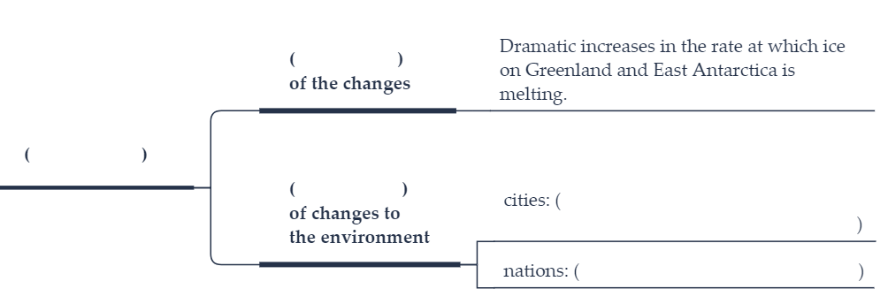

Text 6

I. summarize each paragraph in one sentence or phrase

|  |  |
| --- | --- |
| Text | Summary |
| The past year has starkly illustrated how pervasive and deep-rooted the disinformation problem is in American society. We learned, for example, of the shocking revelations that the information associated with 87 million Facebook users had been illegally accessed by Cambridge Analytica. |  |
| Centrally responsible for the stubbornness of the disinformation problem is the business model that sits at the heart of the internet itself—a business model that is premised on (1) the creation of borderline-addictive web-based services that enjoy a network effect; (2) the unchecked collection of personal data through those services to create behavioral profiles; and (3) the development and implementation of opaque algorithms that curate content in our social feeds and target ads at us. |  |
| These practices are as remarkably simple as they are exploitative of our individual autonomy, and they align well with the phenomenon of motivated cognition—the idea that the way in which individuals perceive, interact and operate in their environment is biased towards achieving an outcome most favorable to them. |  |
| Within the digital realm, this disinformation problem is caused by what could be considered a newer form of motivated cognition: the social media filter bubble. Social media platforms are built to promote the content that we are likeliest to engage with by collecting data about us, create ever more precise advertising profiles. As motivated cognition takes hold of us online, we are increasingly pushed into filter bubbles as a given platform recognizes what kind of person we are. |  |
| Algorithm designers want to keep us on the platforms for as long as possible, and they know that to do that they have to show us the content we are likeliest to agree with. Understanding the factors that enable these bubbles to thrive is key to dampening its role in curtailing engagement between individuals or groups holding opposing views. |
| One potential factor to consider is the reported feelings of loneliness—the perceived mismatch between one’s desired depth of social connectedness and what actually experience—found across all age groups. And while younger individuals may experience feelings of loneliness more than older people, there is a compelling demographic and emerging empirical case to focus on the older population segment. |  |
| In a nationally representative survey, 36 percent of older adults aged 60-69 and 24 percent aged 70 and over in the survey were found to be lonely on a widely used loneliness index. This is especially alarming when considering the harmful health consequences loneliness has on physical and mental health, including its impacts on cognitive functions. |  |
| With recent evidence that older adults are much more likely to disseminate fake news compared with their younger counterparts, coupled with the projected growth for this population segment in the decades to come, it is crucial to advance our understanding of the factors affecting the ways in which older adults engage with these platforms and how-in turn these platforms are affecting how they function in society. |  |

II. What is the issue?

III. Mind-map

